1. Grade Checker
Take a score as input and print the grade based on the following:
90+ : "A"
80-89 : "B"
70-79 : "C"
60-69 : "D"
Below 60 : "F"
here we used a basic if else statement to carry out marks and all.
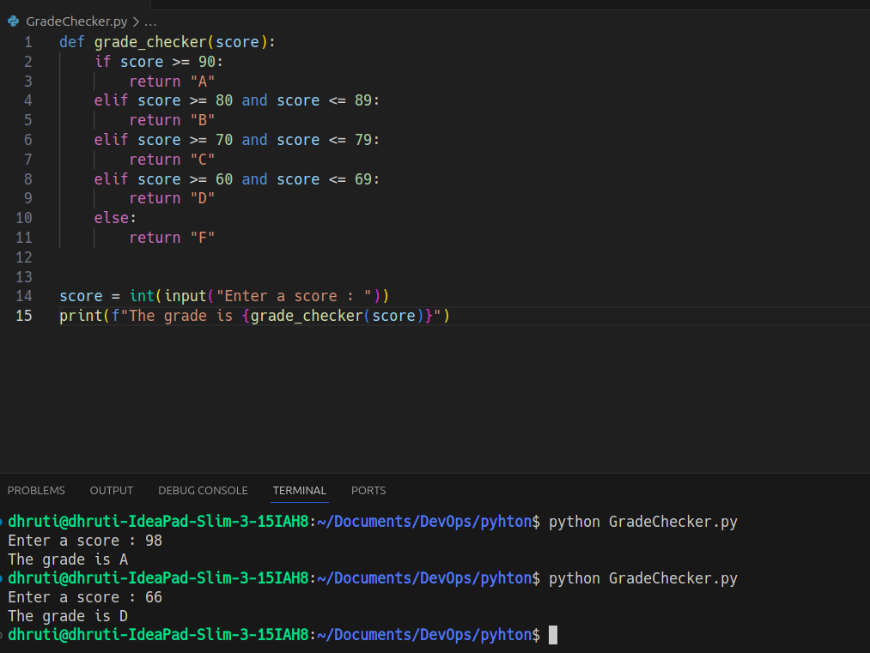
- Enter a score: 98
For a score of 98, it will give a grade of "A".
- Enter a score: 66
For a score of 66, it will give a grade of "D".

2. Student Grades
Create a dictionary where the keys are student names and the values are their grades. Allow the user to:
Add a new student and grade.
Update an existing student’s grade.
Print all student grades.
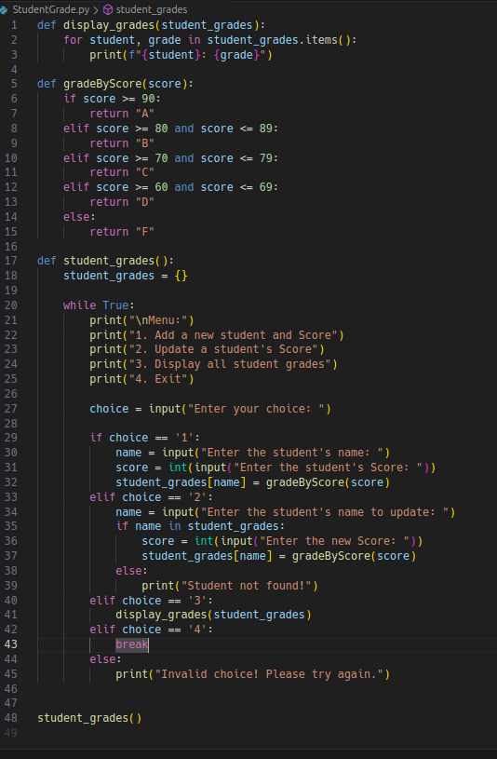

display_grades(student_grades) function
This function takes a dictionary called student_grades as input and prints out the names and grades of all students stored in that dictionary.

gradeByScore(score) function
This function takes a score as input and returns the corresponding grade.

student_grades() function
This function is the main part of the program, where the user interacts with the system to add/update student scores or display all grades. It uses a loop to keep the program running until the user chooses to exit.
- First, you choose "1" to add a student and score:
Input: John, 78
The grade is calculated as "C" (since 78 falls between 70-79).
The program stores John: C in student_grades.
Then, you choose "1" again to add another student and score:
Input: Harry, 93
The grade is calculated as "A" (since 93 is greater than 90).
The program stores Harry: A in student_grades.
Finally, you choose "3" to display all student grades:
John: C
Harry: A

3. Write to a File
Write a program to create a text file and write some content to it.
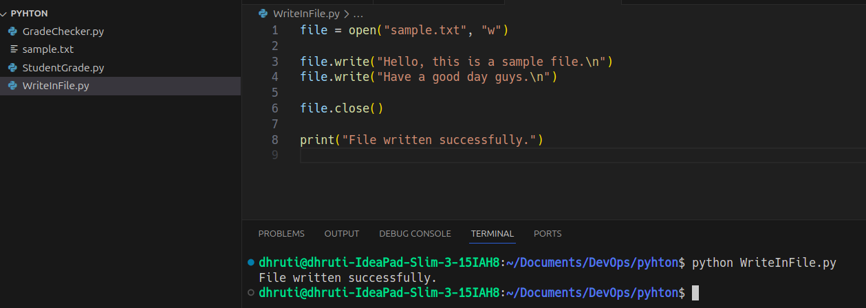
- open("sample.txt", "w"): Opens or creates a file named sample.txt in write mode. If the file already exists, its content will be overwritten.
- file.write(): Writes a string to the file. Each write() adds text to the file.
- \n: Newline character to move to the next line.
- file.close(): Always close the file after you're done to save the content and free up system resources.
- print(): Confirms that the operation was successful.
It will create a file if it does not exist or truncate the existing file and then insert the values inside that file.

4. Read from a File
We used open in read mode and file.read to read and print to display.
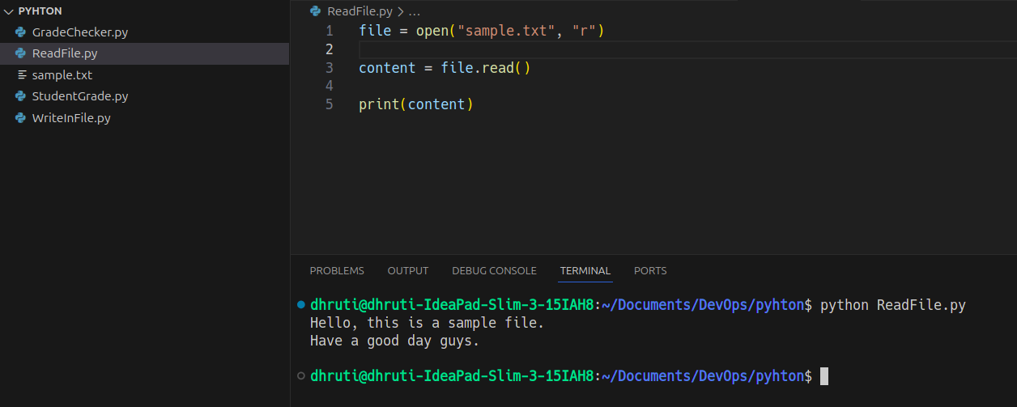
- open("sample.txt", "r"): Opens the file in read mode. The file must already exist.
- file.read(): Reads the entire content of the file as a single string.
- print(content): Displays the content on the console.

